The firewall is connected in a test lab to another firewall using a 192.168.99.0/24 IP address, and the VLAN99 interface which uses the same IP pool is still enabled. Note: the VLAN99 interface is enabled but the status is down:
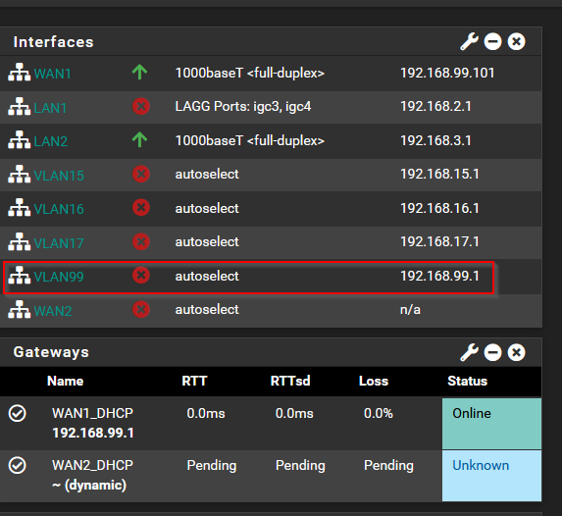
- No connection to the Internet:
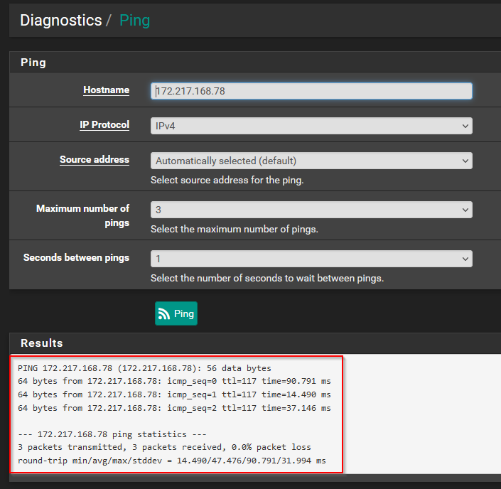
- The VLAN99 interface cannot be disabled while the WAN1 interface is still connected:
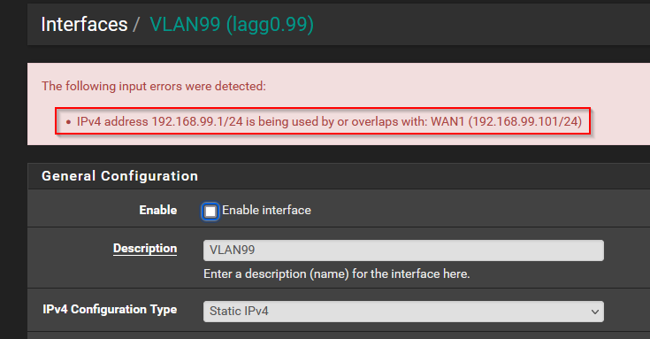
- After physically disconnecting the WAN1 port, the VLAN99 interface can now be disabled:
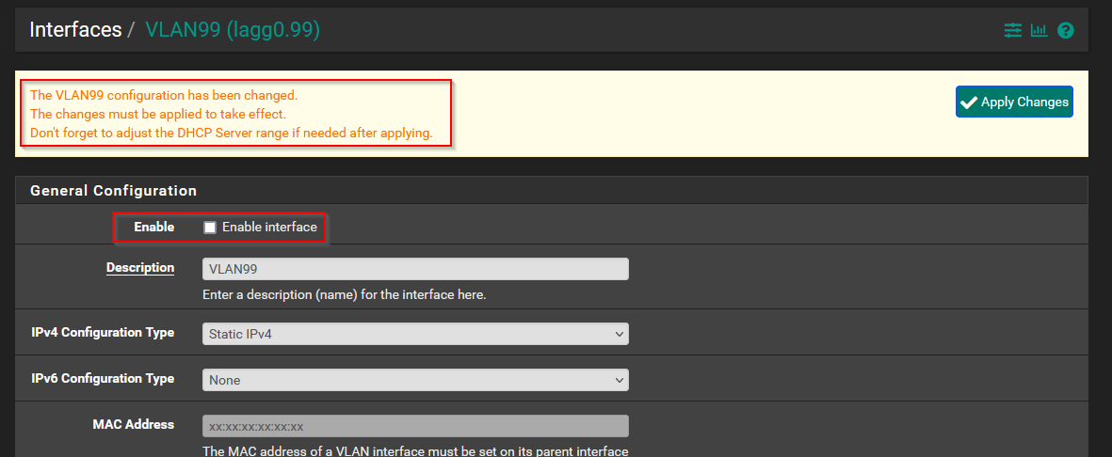
- After plugging in WAN1 again, now we have a connection to the Internet again, too:

