Jonathan Lee
CSC Sacramento State
Summer Researching
6-2-2023
Fingerprinting Docker’s Kali Container with p0f
- Install docker
sudo apt install docker.io -y
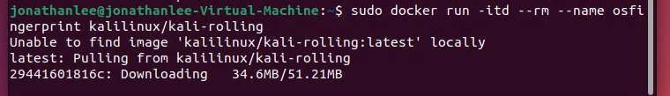
- install Kali Docker container
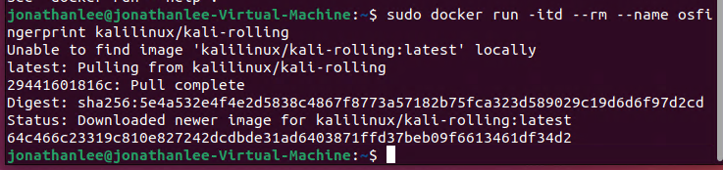

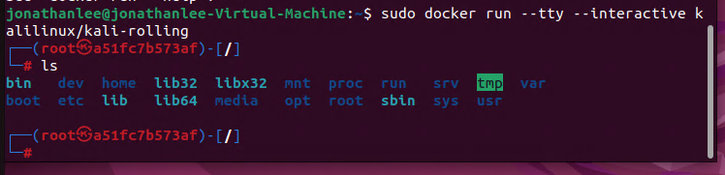
- run a container or just run interactive
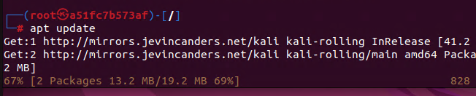

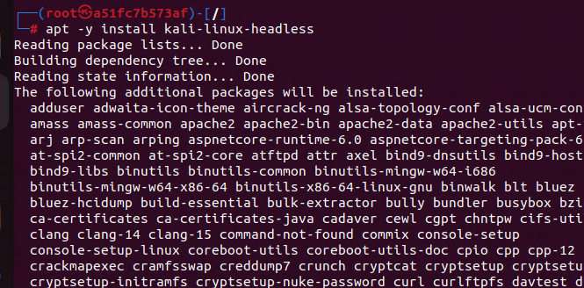
- apt update
- apt -y install kali-linux-headless
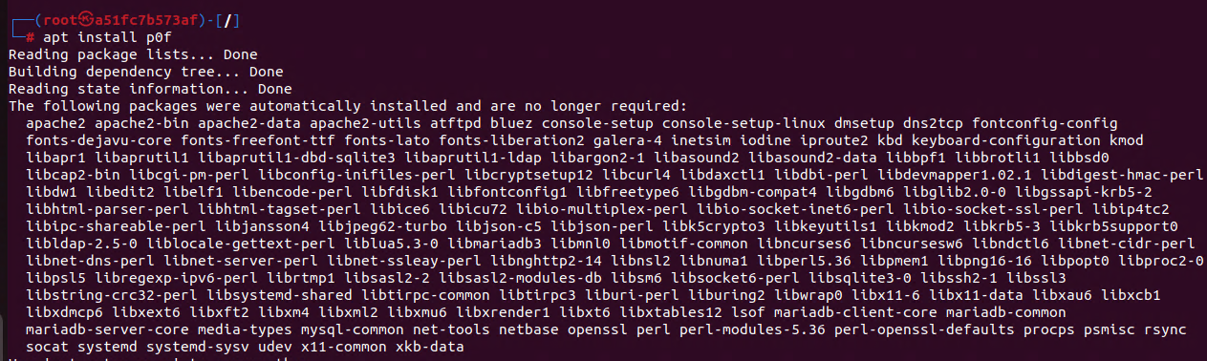
- apt install p0f
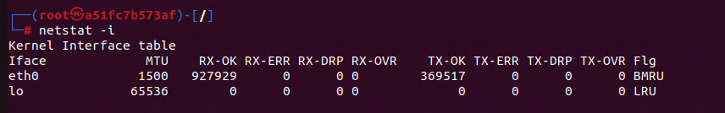
- get the network interface name

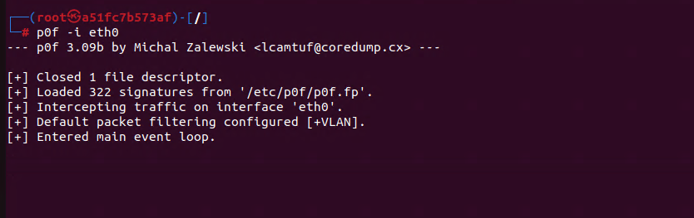
- now run p0f -I eth0
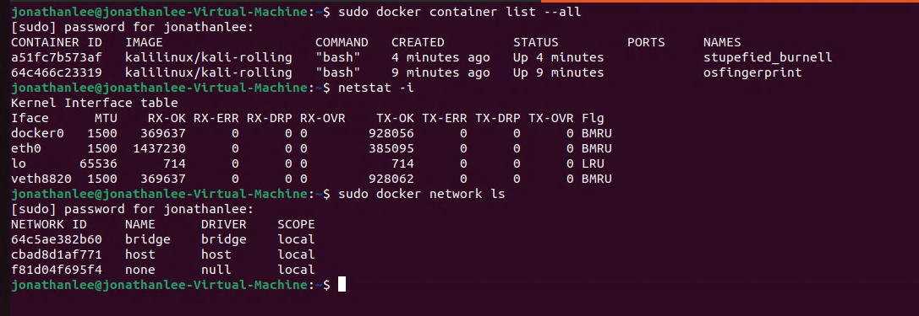
- Open a new window in Ubuntu check check what container you are running kali in for this version I am using a51fc7b57af as seen in the root@ section
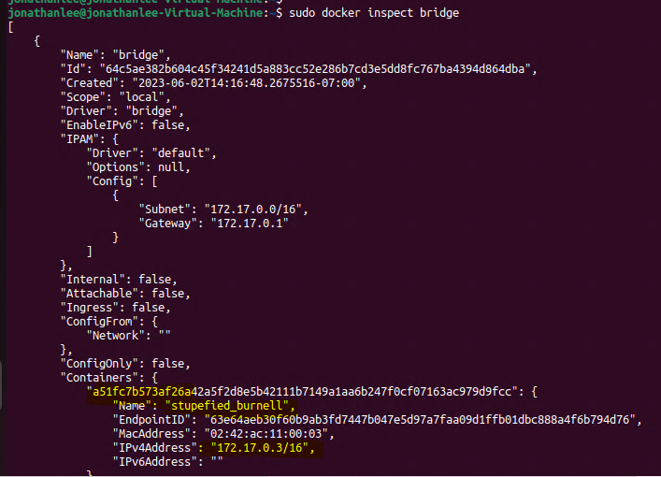
- Sudo docker inspect bridge shows ip of kali
- Sudo docker ps
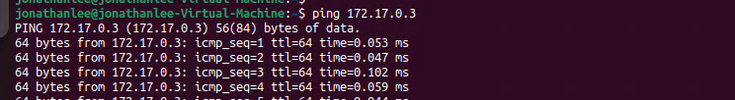
- These match so start pings to get traffic going on this address if it pings move to next step cancel ping

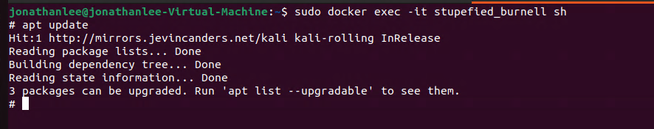
- Login to the container in the other window while still running p0f in the other
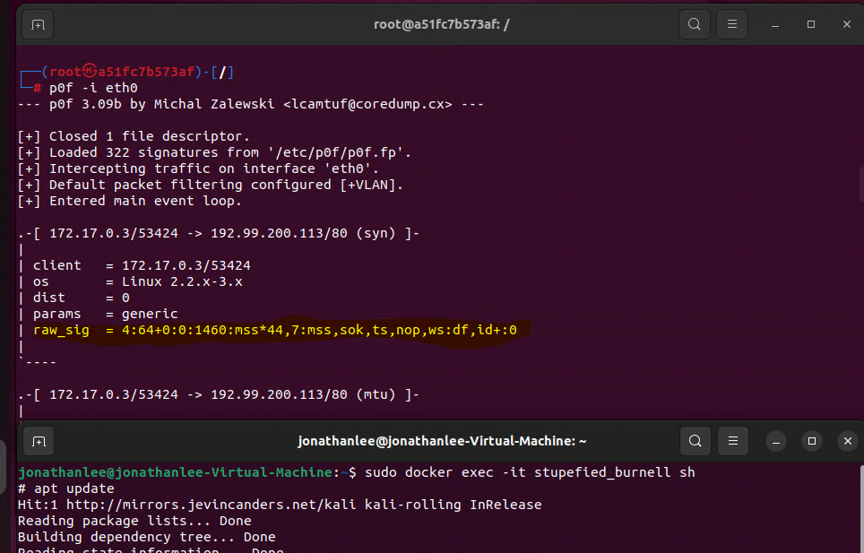
4:64+0:0:1460:mss*44,7:mss,sok,ts,nop,ws:df,id+:0
This signature is the OS fingerprint
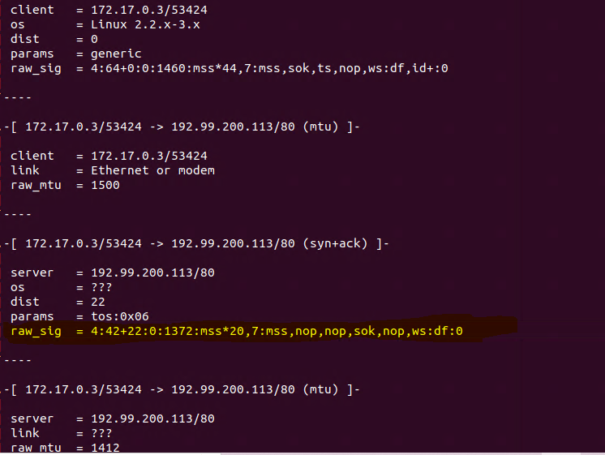
Docker’s Kali Container is 4:42+22:0:1372:mss*20,7:mss,nop,nop,sok,nop,ws:df:0

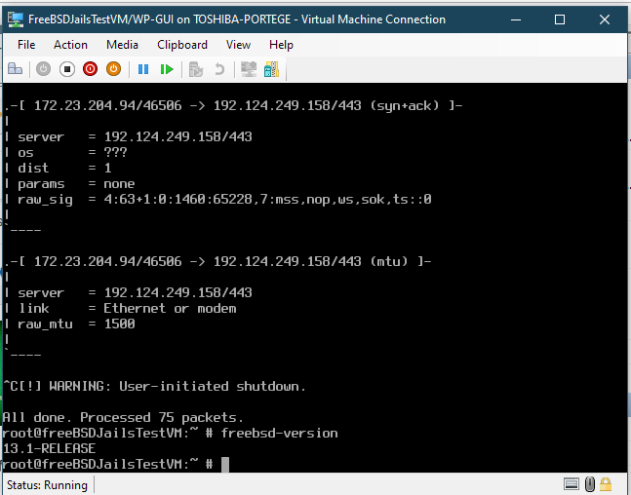
Here is it again in FreeBSD
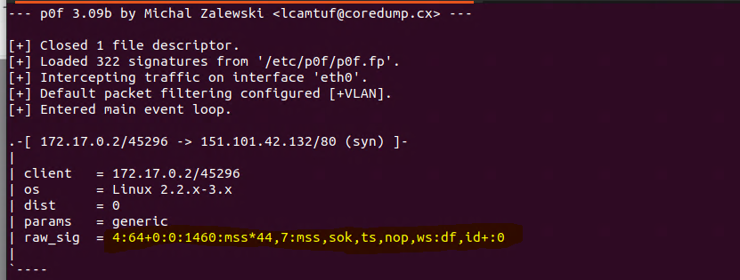
Here it is again for a Debian docker container.

Works Cited:
“Using Kali Linux Docker Images: Kali Linux Documentation.” Kali Linux, 6 Mar. 2023, www.kali.org/docs/containers/using-kali-docker-images/.
“P0F: Kali Linux Tools.” Kali Linux, 5 Aug. 2022, www.kali.org/tools/p0f/.
“You Need to Learn Docker Right Now!! // Docker Containers 101.” YouTube, 2 Apr. 2020, www.youtube.com/watch?v=eGz9DS-aIeY.

